Naked Object with Microsoft Entity Framework
It is a Microsoft based Framework created by founder of the naked object patter Richard Pawson's. The framework implements the programming parading to provide a tool to rapid development of business applications. Being written by the creator of the parading it clearly submits to the three main concepts already explained on the chapter ‘Programming Paradigms’ with are:

-All logic is encapsulated in business objects.
-The interface is a direct representation of the objects definitions in the domain model.
-The interface is directly generated from the domain model.

Although it is a Microsoft framework not for java programming and not for web applications I decided to included in the research because it is a pure implementation of the ‘naked objects’ paradigm and we could extract from it some ideas to apply in our framework.

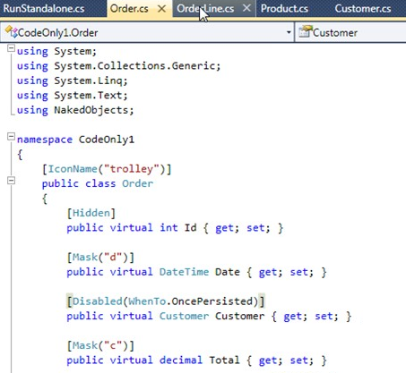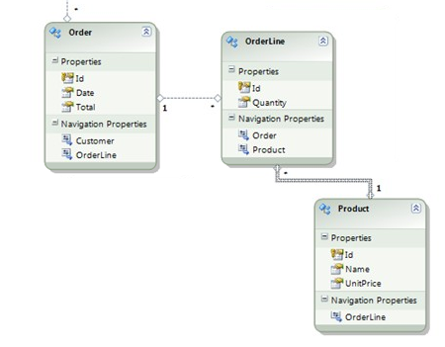

Business objects definition
The business object can be created in three different ways, from a class diagram, from a database or from the code directly. Any of the methods will end up creating class files for each domain object. The type of the file is POCO (Plain Old CLR objects) what are basically a clean class that does no implement any interface or inherit from any other class. Like other frameworks it defines formatting constrains like date formats as well as the presentation constrains like the ‘hidden’ tag we can see on the capture or the ‘disable when …’ with also is interpreted while generated the OOUI. The difference with other framework is that here the developer does no have any control over the presentation layer do the capabilities of the definitions must be greater like for example setting the icon to represent the entity it self, as it is shown in the image.

Site / application layout - Generated life-cycle views CRUD – Labels – Components / Actions - Templates
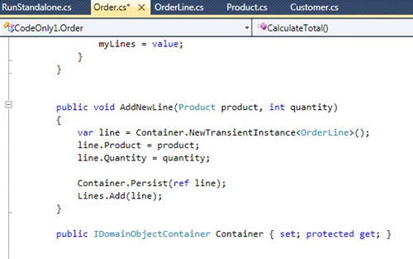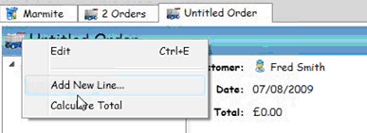

In this framework this is totally generated from the specification of the domain model. Basically there are two elements that govern the generation of the UI:

1 - The first one is the definition of the domain objects; there are not getters and setters explicitly defined, just virtual attributes are their annotations as we have mentioned just before. Apart from that, each public method of the domain object will be an ‘action’ that will be available when ever you do right click on the object.

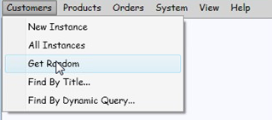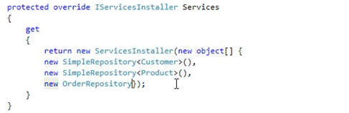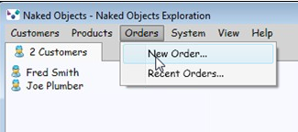
2 - The second element is called ‘services’, services are linked to a specific domain class and its main purpose is to allow retrieving or creating objects from of that domain class. You have to define what services you want to use and they appear like elements in the first tab menu and are considered the starting point of any transaction in OOUI. You can use standard services that provides the standard CRUD functionality plus search capability or you can define you own services with your own methods. A very interesting thing is that if you define a method on one service that has as a parameter one domain object then this method is considered as another action on the domain object it self and can be invoked allow with the other actions of the object when you right-click.

Labels are intelligently derived from the domain classes’ names and attributes, but changing labels it is also possible.

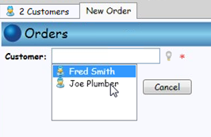
Another usability feature that it relevant for us is that the application keeps of the domain objects open by the user as tabs. This subset of domain objects appear a candidate to be selected when ever a domain object needs to related to another domain object.

Proposal of change – historic record of visited domain entities
We currently keep in memory, in our application, the last search results against any domain object along with the last open domain object. But having a third option which is all the domain objects visited by this user during this session, is an interesting one. Actually this would cover at least the 90% of the cases when we need to select an entity in order to associate with another entity. One clear example of this is the process of creating a communications, a communication needs to be linked to one or more people (who are going to received that communication), currently we ether show the last person, and this is normally not enough, or we need to search in order to add more receivers. With this feature the system would suggest a initial subset of people records which have been already open by the user of the system.

Storage and database
This framework will generated the database classes for you when ever you create domain objects. You have a database configuration setting to choose the database and you can use any ODBC database.

The bad points
One of the bad points of this framework is that it does not easily allows you to create flow-control based processes like wizards and is it has some serious deficiencies in usability like for example in the way you link business objects if they have not been open by the client(you need to use copy and paste).

Good points
Really rapid application development and prototyping.

